Airlines Analysis

# Find list of Airports operating in the Country India

**Query using PIG:**

airport = load '/project/airports_mod.dat' using PigStorage(',') as (portid:chararray,name:chararray,city:chararray,country:chararray,faacode:chararray,icaocode:chararray,latitude:double,longitude:double,altitude:long,timezone:float,dst:chararray,timetz:chararray);

port_india = filter airport by country == 'India';

Ports = foreach port_india generate name as AirPort;

store Ports into '/project/Result_1';

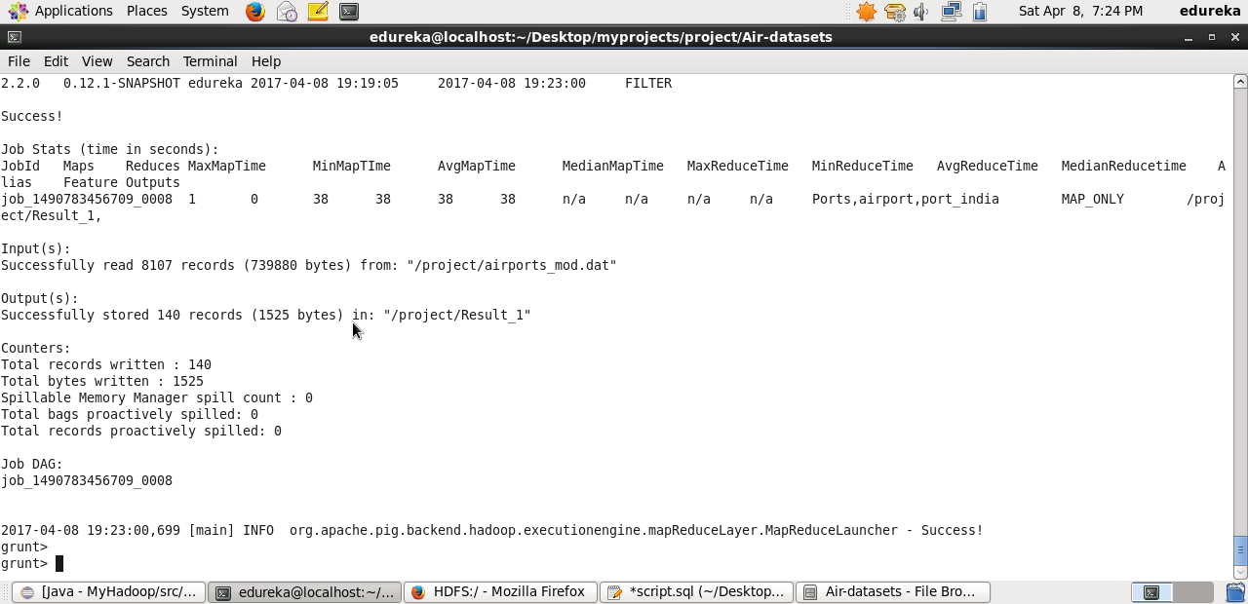

# Find the list of Airlines having zero stops

**Hive Script:**

create external table airlines (id string,name string,alias string,iata string,icao string,callsign string,country string,isactive string)row format delimited fields terminated by ',';

load data inpath '/project/Final_airlines' overwrite into table airlines;

create external table routes (code string,id string,source string,sourceid string,dest string,destid string,codeshare string,stops int,equip string) row format delimited fields terminated by ',';

load data inpath '/project/routes.dat' overwrite into table routes;

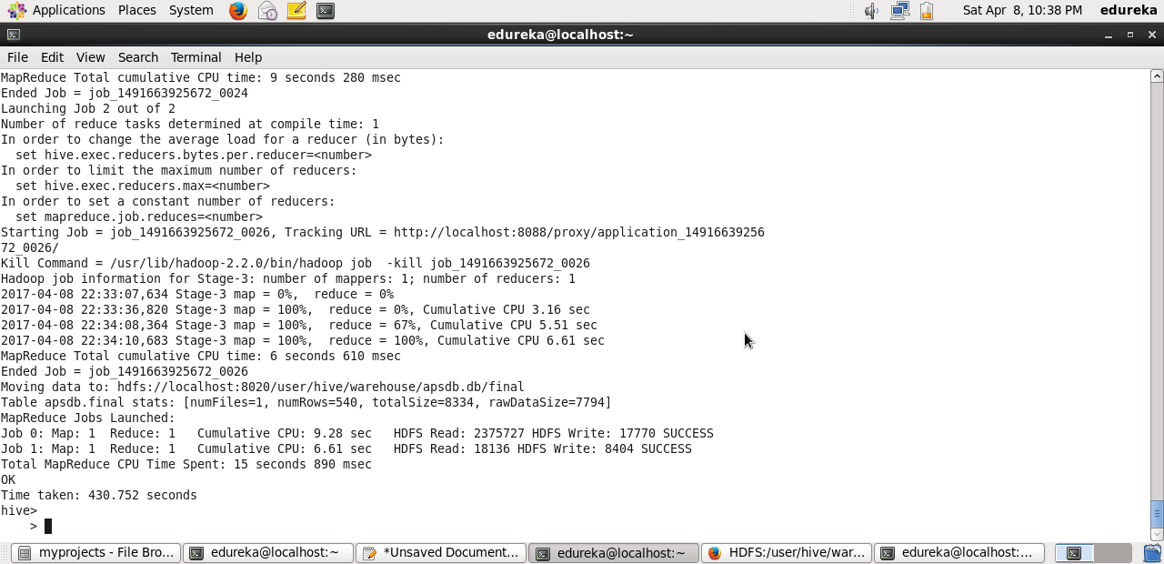

**Pig Script:**

routes = load '/project/routes.dat' using PigStorage(',') as (code:chararray,id:chararray,source:chararray,sourceid:chararray,dest:chararray,destid:chararray,codeshare:chararray,stops:int,equip:chararray);

airlines = load '/project/Final_airlines' using PigStorage(',') as (id:chararray,name:chararray,alias:chararray,iata:chararray,icao:chararray,callsign:chararray,country:chararray,isactive:chararray);

filt = filter routes by stops == 0;

combi = join filt by id, airlines by id;

zerostops = foreach combi generate airlines.name;

final = DISTINCT zerostops;

final = order final by name;

store final into '/project/Result_2';

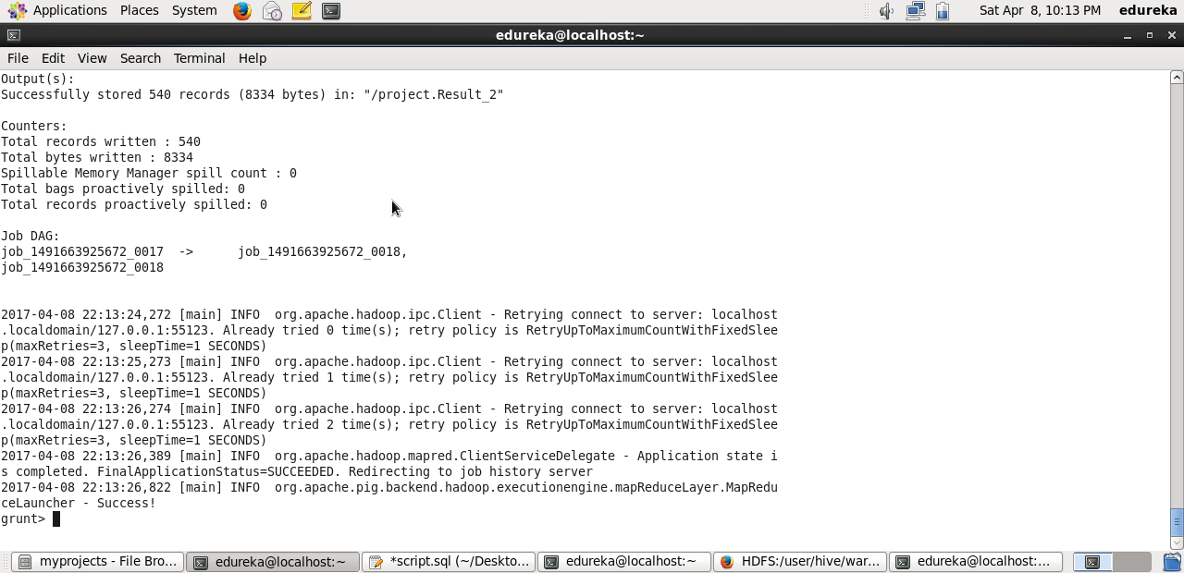

# List of Airlines operating with code share

**Hive Script**

create table codeshare as select DISTINCT(a.name) from airlines a, routes b where a.id=b.id and b.codeshare = 'Y' order by a.name;

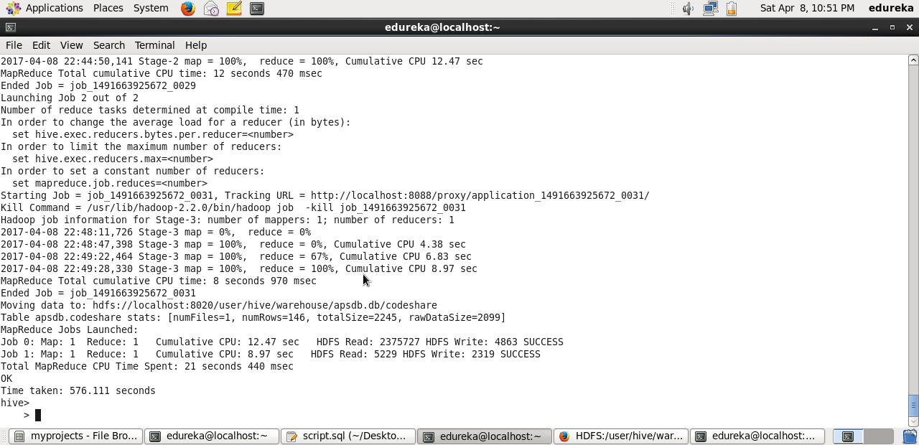

# Which country (or) territory having highest Airports

**Hive Scripts:**

**create external table airport(portid string,name string,city string,**

**country string,faacode string,icaocode string,latitude string,longitude string,**

**altitude string,timezone string,dst string,timetz string)**

**row format delimited fields terminated by ',';**

**load data local inpath '/home/edureka/Desktop/myprojects/project/Air-datasets/airports_mod.dat' overwrite into table airport;**

**select country,cnt from (select country,cnt, rank() over (order by cnt desc) as r from (select country, count(country) as cnt from airport group by country) m ) S where S.r=1;**

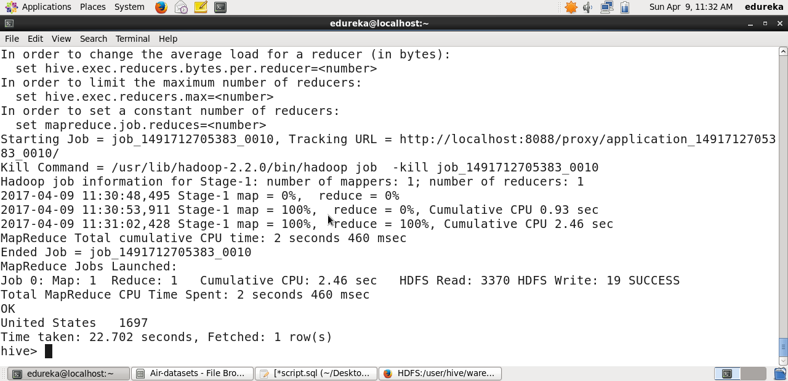

# Find the list of Active Airlines in United state

**Hive Script**

create table activelines as select name from airlines where isactive = 'Y' and country = 'United States' order by name;

